- Directory Structure in Linux
- In Linux/Unix operating system everything is a file even directories are files, files are files, and devices like mouse, keyboard, printer, etc are also files. Here we are going to see the Directory Structure in Linux.
Types of files in the Linux system.
- General Files – It is also called ordinary files. It may be an image, video, program, or simple text file. These types of files can be in ASCII or Binary format. It is the most commonly used file in the Linux system.
- Directory Files – These types of files are a warehouse for other file types. It may be a directory file within a directory (subdirectory).
- Device Files – In a Windows-like operating system, devices like CD-ROM, and hard drives are represented as drive letters like F: G: H whereas in the Linux system devices are represented as files. As for example, /dev/sda1, /dev/sda2, and so on.
We know that in a Windows-like operating system, files are stored in different folders on different data drives like C: D: E: whereas in the Linux/Unix operating system files are stored in a tree-like structure starting with the root directory as shown in the below diagram.
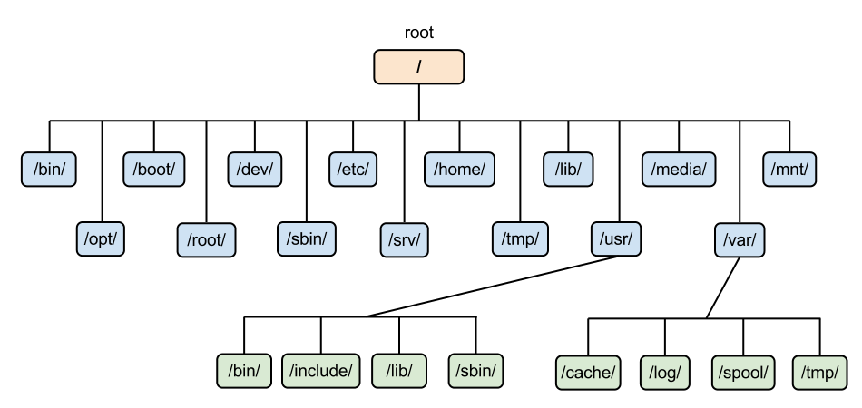
- The Linux/Unix file system hierarchy base begins at the root and everything starts with the root directory.
- These are the common top-level directories associated with the root directory:
Directories | Description
/bin | binary or executable programs.
/etc | system configuration files.
/home | home directory. It is the default current directory.
/opt | optional or third-party software.
/tmp | temporary space, typically cleared on reboot.
/usr | User related programs.
/var | log files.
Some other directories in the Linux system:
Directories | Description
/boot | It contains all the boot-related information files and folders such as conf, grub, etc.
/dev | It is the location of the device files such as dev/sda1, dev/sda2, etc.
/lib | It contains kernel modules and a shared library.
/lost+found | It is used to find recovered bits of corrupted files.
/media | It contains subdirectories where removal media devices are inserted.
/mnt | It contains temporary mount directories for mounting the file system.
/proc | It is a virtual and pseudo-file system to contains info about the running processes with a specific process ID or PID.
/run | It stores volatile runtime data.
/sbin | binary executable programs for an administrator.
/srv | It contains server-specific and server-related files.
/sys | It is a virtual file system for modern Linux distributions to store and allows modification of the devices connected to the system.
Exploring directories and their usability:
- We know that Linux is a very complex system that requires an efficient way to start, stop, maintain and reboot a system, unlike Windows operating system. In the Linux system some well-defined configuration files, binaries, main pages information files are available for every process.
Linux Kernel File:
- /boot/vmlinux – The Linux kernel file.
- Device Files:
- /dev/hda – Device file for the first IDE HDD.
- /dev/hdc – A pseudo-device that output garbage output is redirected to /dev/null.
System Configuration Files:
Configuration Files | Description
/etc/bashrc | It is used by bash shell that contains system defaults and aliases.
/etc/crontab | A shell script to run specified commands on a predefined time interval.
/etc/exports | It contains information on the file system available on the network.
/etc/fstab | Information of the Disk Drive and their mount point.
/etc/group | It is a text file to define Information of Security Group.
/etc/grub.conf | It is the grub bootloader configuration file.
/etc/init.d | Service startup Script.
/etc/lilo.conf | It contains lilo bootloader configuration file.
/etc/hosts | Information of IP and corresponding hostnames
/etc/hosts.allow | It contains a list of hosts allowed accessing services on the local machine.
/etc/host.deny | List of hosts denied accessing services on the local machine.
/etc/inittab | INIT process and their interaction at the various run levels.
/etc/issue | Allows editing the pre-login message.
/etc/modules.conf | It contains the configuration files for the system modules.
/etc/motd | It contains the message of the day.
/etc/mtab | Currently mounted blocks information.
/etc/passwd | It contains username, password of the system, users in a shadow file.
/etc/printcap | It contains printer Information.
/etc/profile | Bash shell defaults.
/etc/profile.d | It contains other scripts like application scripts, executed after login.
/etc/rc.d | It avoids script duplication.
/etc/rc.d/init.d | Run Level Initialisation Script.
/etc/resolv.conf | DNS being used by System.
/etc/security | It contains the name of terminals where root login is possible.
/etc/skel | Script that initiates new user home directory.
/etc/termcap | An ASCII file that defines the behavior of different types of the terminal.
/etc/X11 | Directory tree contains all the conf files for the X-window System.
User Related Files:
User Related Files | Descriptions
/usr/bin | It contains most of the executable files.
/usr/bin/X11 | Symbolic link of /usr/bin.
/usr/include | It contains standard files used by C program.
/usr/share | It contains architecture independent shareable text files.
/usr/lib | It contains object files and libraries.
/usr/sbin | It contains commands for Super User, for System Administration.
Virtual and Pseudo Process Related Files:
Virtual and Pseudo Process Related Files | Descriptions
/proc/cpuinfo | CPU Information
/proc/filesystems | It keeps useful info about the processes that are currently running.
/proc/interrupts | it keeps the information about the number of interrupts per IRQ.
/proc/ioports | Contains all the Input and Output addresses used by devices on the server
/proc/meminfo | It reports the memory usage information.
/proc/modules | Currently using kernel module.
/proc/mount | Mounted File-system Information.
/proc/stat | It displays the detailed statistics of the current system.
/proc/swaps | It contains swap file information.
Version Information File:
/version – It displays the Linux version information.
Log Files:
Log Files | Descriptions
/var/log/lastlog | It stores user’s last login info.
/var/log/messages | It has all the global system messages
/var/log/wtmp | It keeps a history of login and logout information.
To check the Linux directories, open the terminal and execute sudo -s followed by the system password to give root privileges. Then, after changing the current home directory to the root directory, check the list of all available directories in the base directory, as shown below.
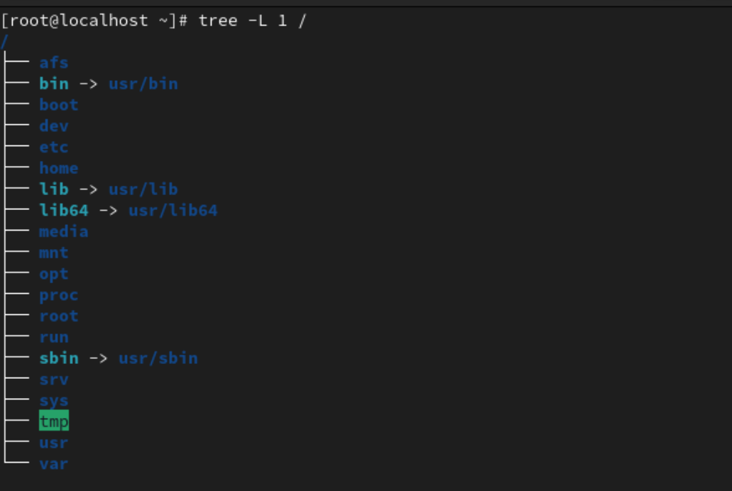
Conclusion
- If we understand the Linux directory’s structure correctly, it would be so easy to effectively navigate and manage our filesystem, locate important configuration files, and access system information. One must know that the directory structure and specific file mentioned in this article are based on standard Linux conventions.
- We must consider that the different Linux distributions may have variations in the directory structure and specific file locations, but overall concept and organization remain similar.

2. Interview Questions
Q: What is the Linux Directory Structure?
- A: The Linux Directory Structure, also referred to as the Filesystem Hierarchy Standard (FHS), defines a standardized way to organize files and directories on a Linux system. This structure ensures consistency and makes it easier for users and administrators to find what they need.
Q: What is the root directory (/) and why is it important?
A: The root directory (/) is the top level directory in the Linux file system hierarchy. It acts as the starting point for all other directories and files. Everything in the Linux system resides below the root directory.
Q: Can you explain some of the major directories within the structure?
A: Sure! Here are some key directories and their purposes:
- /bin: Contains essential binary executable files needed for basic system operations and accessible to all users (e.g., cat, ls, cp).
- /boot: Stores files required for booting the system, including the kernel and configuration files.
- /etc: Houses system-wide configuration files for applications, services, and the operating system itself.
- /home: Contains individual user home directories where personal files, configurations, and data are stored.
- /lib: Stores essential system libraries used by programs.
- /sbin: Similar to /bin, but contains essential system binaries for administration tasks, typically only accessible to root or privileged users.
- /usr: Contains user-related programs, libraries, documentation, and resources that are not critical for system startup (e.g., compilers, interpreters, applications).
- /var: Stores variable data that changes frequently, such as logs, spool directories, and temporary files.
Q: How does the directory structure help with file management?
A: The structure promotes organization by grouping related files together. This makes it easier to locate specific files and keeps the system clutter-free. Knowing the standard locations for different types of files allows users and administrators to quickly navigate and manage the system effectively.
Q: Virtual Filesystems (VFS):
A: How does the VFS layer work?
The VFS acts as an abstraction layer between the applications and the physical storage devices. It provides a unified interface for accessing different types of filesystems (ext4, XFS, etc.) regardless of their underlying implementation. The VFS translates user requests into operations that the specific filesystem understands.
Q: Advanced Directory Management Techniques:
- A: Hard links vs. symbolic links:
  - Hard links: Point to the same inode (data block) on the disk. Changes to one file are reflected in the other. Limited to the same filesystem.
  - Symbolic links: Point to the location of another file or directory. Independent files, changes to the link target won't affect the link itself. Can link across filesystems.
Use hard links when multiple names are needed for the same file within the same file system. Use symbolic links for flexibility, like creating shortcuts to files in different locations.
- A: Automating directory management:
Shell scripting with tools like find (locate files) and xargs (execute commands on multiple files) can automate tasks like backing up specific directories or changing permissions on a group of directories.
- A: Managing directory permissions:
Use chmod to change permissions (read, write, execute) for users, groups, and others. Use ownership (chown) and group ownership (chgrp) to control who can access and modify directories. Set permissions strategically to ensure system security while allowing authorized users access.
Q: Special Directories and Files:
- A: Purpose of the /dev directory:
The /dev directory contains device files that represent physical devices like hard drives, keyboards, and printers. Programs interact with these files to access the devices.
- A: FUSE (Filesystem in Userspace):
FUSE allows custom filesystems to be developed and mounted within the FHS. These filesystems run in user space, providing flexibility for specialized functionality (e.g., encrypted filesystem, remote filesystem access).
- A: Managing temporary directories like /tmp:
The /tmp directory is used for temporary files created by applications. The system automatically cleans it periodically. Security considerations: avoid storing sensitive data in /tmp as it's publicly writable.
Q: Troubleshooting Directory Issues:
- A: Diagnosing permission errors:
Use ls -l to view directory permissions. Check if you have the necessary permissions (read, write, execute) to access the directory. Use chmod to adjust permissions if needed.
- A: Empty directory with hidden files:
Use ls -a to list all files, including hidden ones (starting with a dot). This might reveal hidden files within the directory.
- A: Using strace to identify programs accessing directories:
The strace tool traces system calls made by a program. Use it to identify programs that are incorrectly accessing directories, helping diagnose unexpected behavior.

