Introduction to Linux
1.1 What is Linux?
- Linux is an open-source operating system kernel originally created by Linus Torvalds in 1991. It is based on the Unix operating system.
- The Linux kernel serves as the foundation of various Linux distributions, commonly referred to as "distros."
- These distributions package the Linux kernel with various software packages and a graphical user interface to create complete operating systems that users can install and use on their computers.
- Key features of Linux include:
- Open Source: Linux is distributed under an open-source license, which means that its source code is freely available to the public. This allows developers to view, modify, and distribute the code, leading to continuous improvement and innovation.
- Multitasking and Multi-user: Linux supports multitasking, allowing multiple processes to run simultaneously. It also supports multiple users, allowing multiple users to log in and use the system simultaneously.
- Stability and Reliability: Linux is known for its stability and reliability. It is commonly used in servers and critical systems where uptime is crucial.
- Security: Linux is inherently more secure than many other operating systems due to its Unix-based architecture, which includes features such as file permissions, user authentication, and robust networking capabilities.
- Flexibility and Customization: Linux is highly customizable, allowing users to tailor their systems to their specific needs. There are many different Linux distributions available, each with its own set of features and software packages.
- Community Support: Linux has a large and active community of users and developers who provide support, documentation, and software development for the platform.

Operating System (OS):
- An operating system (OS) is a software that manages hardware resources and provides services to applications.
- An operating system acts as an intermediary between the hardware and the user, providing a user-friendly interface for interacting with the computer and managing system resources.

1.2 What is a Server?
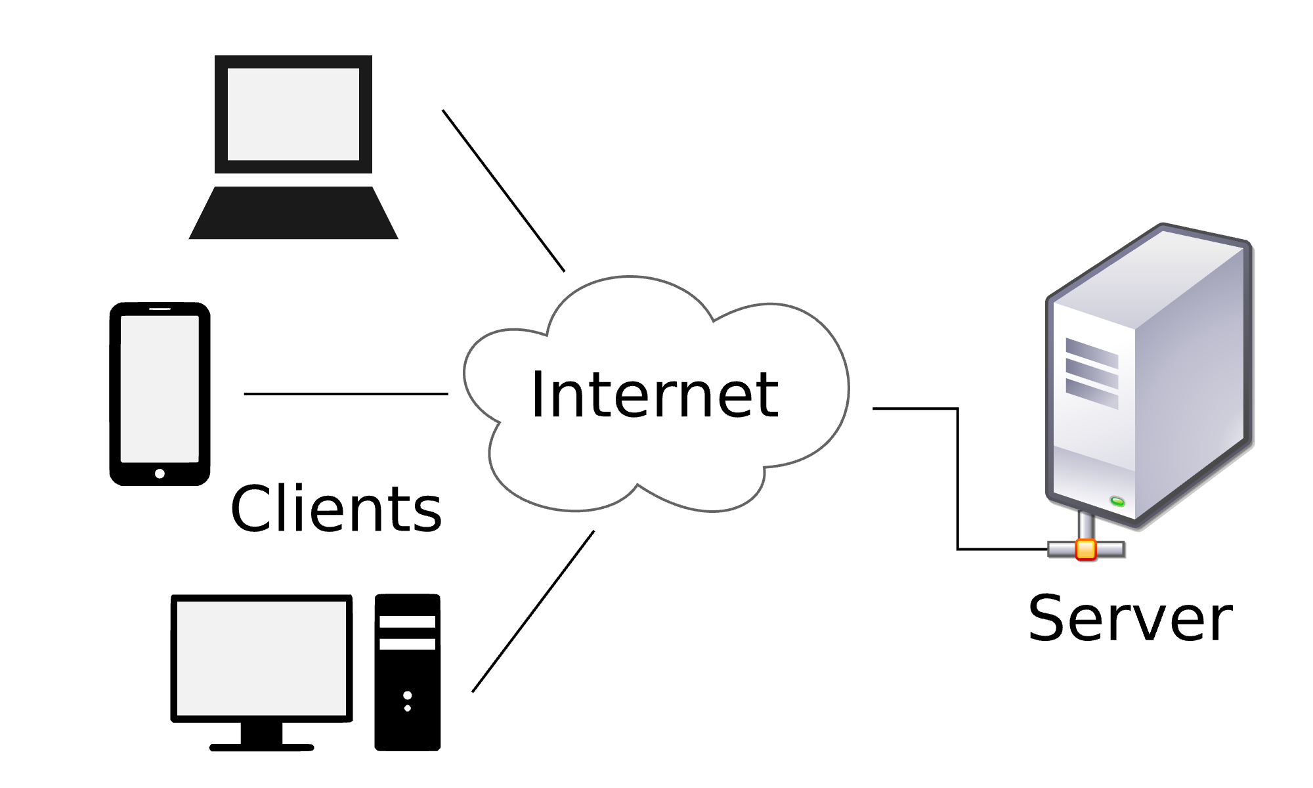

- A server is a computer program or a device that provides functionality or services to other programs or devices, known as clients, over a network. In simpler terms, a server is a specialized computer that "serves" data, resources, or services to other computers, known as clients, over a network.
There are many types of servers, each designed to perform specific tasks or serve specific types of data or applications. Some common types of servers include:
- Web servers: These servers deliver web pages to users' web browsers upon request. Apache and Nginx are popular examples of web server software.
- File servers: These servers store and manage files so that users can access them over a network. They are often used in business environments to centralize file storage and sharing.
- Database servers: These servers manage database management systems (DBMS) and provide access to databases and their data. Examples include MySQL, Oracle, and Microsoft SQL Server.
- Email servers: These servers handle the sending, receiving, and storage of email messages. Examples include Microsoft Exchange Server and Postfix.
- Game servers: These servers host multiplayer online games, allowing multiple players to interact and play together in real-time.
- Application servers: These servers host and manage software applications, providing services such as application execution, security, and data access.

1.3 Components of OS
- An operating system (OS) is system software that manages computer hardware, software resources, and provides common services for computer programs. The operating system acts as an intermediary between computer hardware and software applications, making it easier for users to interact with the computer.
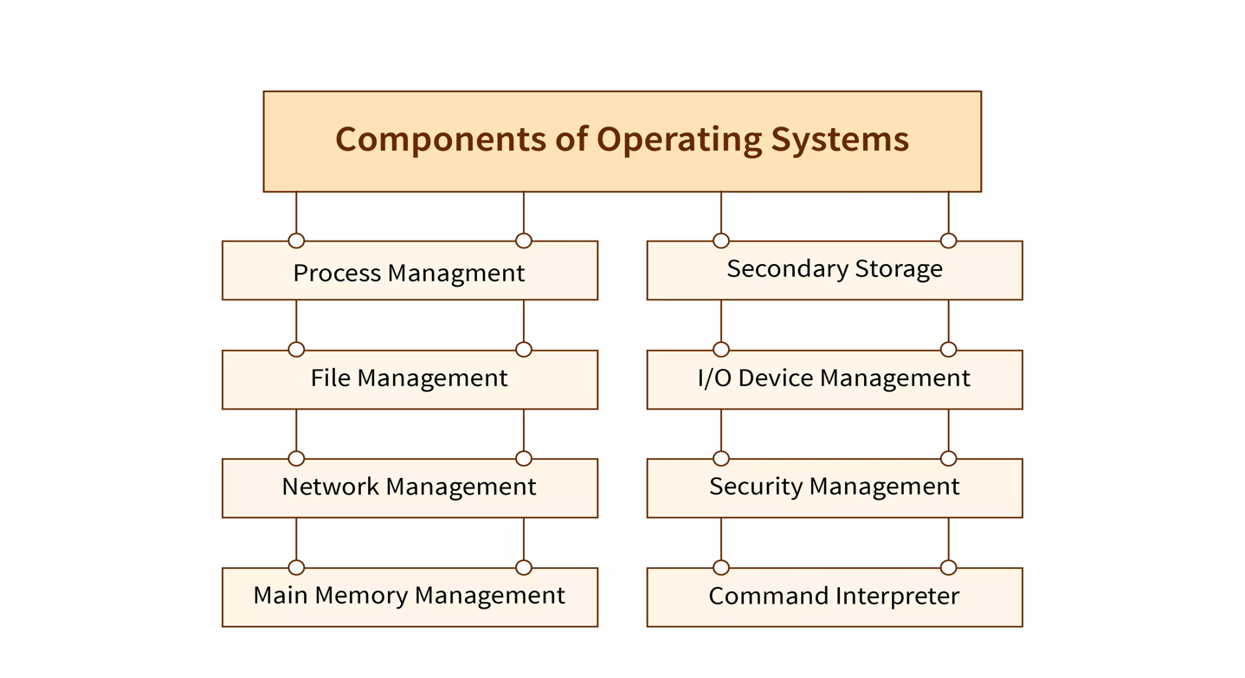
1.4 Components of Linux Operating System:
a. Kernel:
- The kernel is the core component of the Linux operating system. It manages the system's hardware resources, such as the CPU, memory, disk drives, and peripheral devices.
- The Linux kernel provides essential services, including process management, memory management, device management, and system calls.
b. Shell:
- The shell is a command-line interface that allows users to interact with the Linux system. It interprets user commands and executes them.
- The most common shell used in Linux is the Bash (Bourne Again Shell), although other shells, such as Zsh (Z Shell) and Fish, are also available.
c. File System:
- The file system organizes and manages the storage of files and directories on the disk.
- Linux supports various file systems, including ext4, XFS, Btrfs, and others.
d. System Libraries:
- System libraries are collections of functions and routines that provide essential functionality to applications and services.
- Common system libraries include the GNU C Library (glibc), the Standard C Library (libc), and others.
e. Utilities:
- Utilities are small programs and tools that perform specific tasks and provide various functionalities to the Linux system.
- Examples of utilities include file management tools (such as ls, cp, mv), text processing tools (such as grep, sed, awk), and system administration tools (such as systemctl, ifconfig, and fdisk).
f. Graphical Server (X Window System):
- The X Window System (X11 or X) provides the graphical framework for Linux desktop environments.
- It manages the display hardware and provides the infrastructure for graphical user interfaces (GUIs) and windowing systems.
- Modern Linux desktop environments, such as GNOME, KDE, and Xfce, are built on top of the X Window System.
g. Desktop Environment:
- A desktop environment is a collection of graphical applications, utilities, and libraries that provide a complete user interface for the Linux desktop.
- Popular Linux desktop environments include GNOME, KDE Plasma, Xfce, LXDE, and Cinnamon.
h. Window Manager:
- The window manager controls the placement and appearance of windows in a Linux graphical environment.
- It manages window decorations, window borders, and window resizing.
- Examples of window managers include Metacity (used by GNOME), KWin (used by KDE), Xfwm (used by Xfce), and Openbox.

1.5 Architecture of Linux Server

- The architecture of a Linux server can be simplified into four layers:
Hardware Layer:
- This layer consists of physical hardware components such as CPU, memory (RAM), storage devices (hard drives, SSDs), network interfaces, and other peripherals.
Kernel Layer:
- The kernel is the core of the Linux operating system.
- It interacts directly with the hardware and provides essential services to the upper layers.
- Manages memory, processes, input/output operations, and hardware resources.
Shell Layer:
- The shell is the interface between the user and the operating system.
- Users interact with the shell through a command-line interface (CLI) or a graphical user interface (GUI).
- The shell interprets user commands and communicates with the kernel to execute them.
Application Layer:
- This layer consists of user-space applications and utilities.
- Applications interact with the kernel through system calls to perform tasks such as file operations, network communication, and process management.
- Examples of applications include web servers, databases, email servers, and other software programs.

1.6 Difference between Linux and Windows
Windows and Linux are two different operating systems, each with its own set of characteristics, strengths, and weaknesses.
- User Interface (UI):
Windows typically offers a graphical user interface (GUI) that is intuitive and easy for beginners to navigate.
Linux distributions provide various GUI options but are often associated with customizable interfaces and offer a lot of flexibility for power users who prefer command-line interfaces (CLI).
- Cost:
- Windows often requires a license fee for each installation, though Microsoft sometimes provides free or discounted versions for certain users (like students).
- Linux is usually free and open-source, meaning you can download, install, and modify it without paying any licensing fees.
- Software Compatibility:
- Windows is widely supported by software vendors, offering a vast array of commercial and free applications. Many popular programs, especially in gaming and creative industries, are primarily developed for Windows.
- While Linux has a growing ecosystem of software, it may not always support the same range of applications as Windows. However, many open-source alternatives exist for common tasks, and compatibility tools like Wine can sometimes enable running Windows software on Linux.
- Customization and Control:
- Linux is highly customizable, allowing users to tailor their systems to their exact needs. This flexibility extends to the choice of desktop environment, system components, and even the core kernel.
- Windows, while providing some customization options, is more restrictive in terms of modifying core system components.
- Security:
- Linux is known for its robust security features. Due to its open-source nature, vulnerabilities are often quickly identified and patched by the community.
- Windows has historically been targeted more by malware and viruses due to its widespread use. However, Microsoft has made significant improvements in security with each new version.

- Support and Community:
- Windows benefits from extensive official support from Microsoft, including regular updates and patches. There is also a vast online community for troubleshooting and assistance.
- Linux distributions are supported by various communities and organizations, offering online forums, documentation, and community-driven development.
- Resource Usage:
- Linux distributions are often favored for their efficiency, particularly on older hardware or in server environments where resources are a concern.
- Windows may be perceived as more resource-intensive, although newer versions have become more optimized.
- Target Audience:
- Windows is often seen as a user-friendly operating system suitable for a wide range of users, including home users, businesses, and gamers.
- Linux is popular among developers, system administrators, and enthusiasts who value its openness, flexibility, and control.
1.7 What is a Distro/Distribution system?
- a "distro," is a version of the Linux operating system that includes the Linux kernel, system libraries, system tools, and additional software such as desktop environments, package managers, and applications. Linux distributions are maintained by individuals, organizations, and communities, and they are typically available for free download and use.
1.7.1 What are the different Distros available?
There are hundreds of Linux distributions available, each with its own goals, features, and target audience. Some of the most popular Linux distributions include:
- Ubuntu: Based on Debian, Ubuntu is one of the most popular desktop Linux distributions. It focuses on usability, ease of installation, and regular releases. Ubuntu is known for its strong community support and extensive software repositories.
- Debian: Debian is a stable and versatile Linux distribution known for its commitment to free and open-source software principles. It serves as the foundation for many other Linux distributions, including Ubuntu and Linux Mint.
- Linux Mint: Based on Ubuntu, Linux Mint is a user-friendly desktop Linux distribution that aims to provide a complete out-of-the-box experience for users. It includes multimedia codecs, proprietary drivers, and a variety of desktop environments.
- Fedora: Sponsored by Red Hat, Fedora is a cutting-edge Linux distribution that focuses on innovation and the latest technologies. It serves as a testing ground for features that may later be included in Red Hat Enterprise Linux (RHEL).
- openSUSE: Developed by the openSUSE Project, openSUSE is a stable and easy-to-use Linux distribution that is suitable for both desktop and server use. It offers a choice of desktop environments and a powerful package management system.
- CentOS: Derived from the source code of Red Hat Enterprise Linux (RHEL), CentOS is a free and open-source Linux distribution that aims to provide a stable and reliable platform for server deployment. It is known for its long-term support and security updates.
- Arch Linux: Arch Linux is a lightweight and flexible Linux distribution that follows a rolling release model, meaning that updates are continuously released rather than in periodic versions. It is designed for users who want to customize their system from the ground up.
- Gentoo: Gentoo is a source-based Linux distribution that allows users to compile and customize their entire system from source code. It is highly customizable and is often used by advanced users and Linux enthusiasts.

