- User in Linux:
- In Linux, a user is an entity that can own files, run processes, and execute commands within the system.
- Users are a fundamental component of Linux's multi-user capability, allowing multiple individuals to use and access the system simultaneously while maintaining security and privacy.
- Each user has a unique username and user ID (UID), and their activities and permissions are governed by the system's user management framework.
1.1 Types of Users
Root User (Superuser):
- The root user has the highest level of access and control over the entire system.
- The root user can perform any operation, including administrative tasks like installing software, changing system configurations, and managing other users.
- The root user has a UID of 0.
Regular Users:
- Regular users have limited permissions compared to the root user.
- They can create, modify, and delete files and directories within their own home directory and execute programs they have permission to run.
- Regular users can’t perform administrative tasks unless they have been granted specific privileges.
System Users:
- System users are created by the system or administrators for specific system services and applications.
- These users typically don’t have a home directory or the ability to log in interactively.
- Examples include users like www-data for web servers and nobody for unprivileged services.
1.2 User Attributes
- Each user in Linux has several associated attributes that define their identity and permissions:
- Username: A unique name that identifies the user. Usernames are typically alphanumeric and can include underscores.
- User ID (UID): A unique numerical identifier assigned to each user. UIDs are used by the system to identify users.
- Group ID (GID): Each user belongs to at least one group. The primary group ID is associated with the user's primary group.
- Home Directory: The directory where a user's personal files and configuration settings are stored. For regular users, this is usually located in /home/username.
- Shell: The command-line interface that the user interacts with upon logging in. Common shells include /bin/bash and /bin/sh.
1.3 Managing Users
Adding a User
- To add a new user, the useradd command is used. It creates a new user account and sets up the home directory and necessary configuration files.
sudo useradd -m username
The -m option creates the home directory for the user.
Setting a Password
- To set or change the password for a user, the passwd command is used.
sudo passwd username
Modifying a User
- To modify an existing user's attributes, the usermod command is used.
sudo usermod -aG groupname username
- The -aG option adds the user to an additional group without removing them from existing groups.
Deleting a User
- To delete a user account, the userdel command is used.
sudo userdel -r username
- The -r option removes the user's home directory and mail spool.
Viewing User Information
- /etc/passwd: This file contains information about all the users on the system, including their usernames, UIDs, GIDs, home directories, and default shells.
cat /etc/passwd
- /etc/shadow: This file contains the encrypted passwords and additional information about password policies for each user.
sudo cat /etc/shadow
- id Command: This command displays the current user's UID, GID, and group memberships: id username
2 Linux Permissions
- Linux permissions are fundamental to maintaining security and managing access to files and directories in a multi-user environment.
- Understanding how to view, modify, and manage these permissions is essential for system administrators and users alike.
2.1 Types of Users associated with file and directory
In Linux, every file and directory is associated with three types of users:
- Owner: The user who owns the file. By default, this is the user who created the file.
- Group: A set of users who share the same permissions on the file. The owner can belong to multiple groups.
- Others: All other users who are not the owner or members of the group associated with the file.
2.2 Permission Types
There are three types of permissions that can be granted to each of the user types:
- Read (r): Permission to read the contents of the file.
- Write (w): Permission to modify or delete the file.
- Execute (x): Permission to execute the file, if it is a script or a program.
Permissions are represented by a sequence of ten characters when using the ls -l command. The format is as follows:

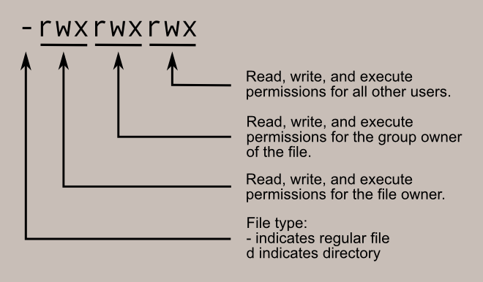
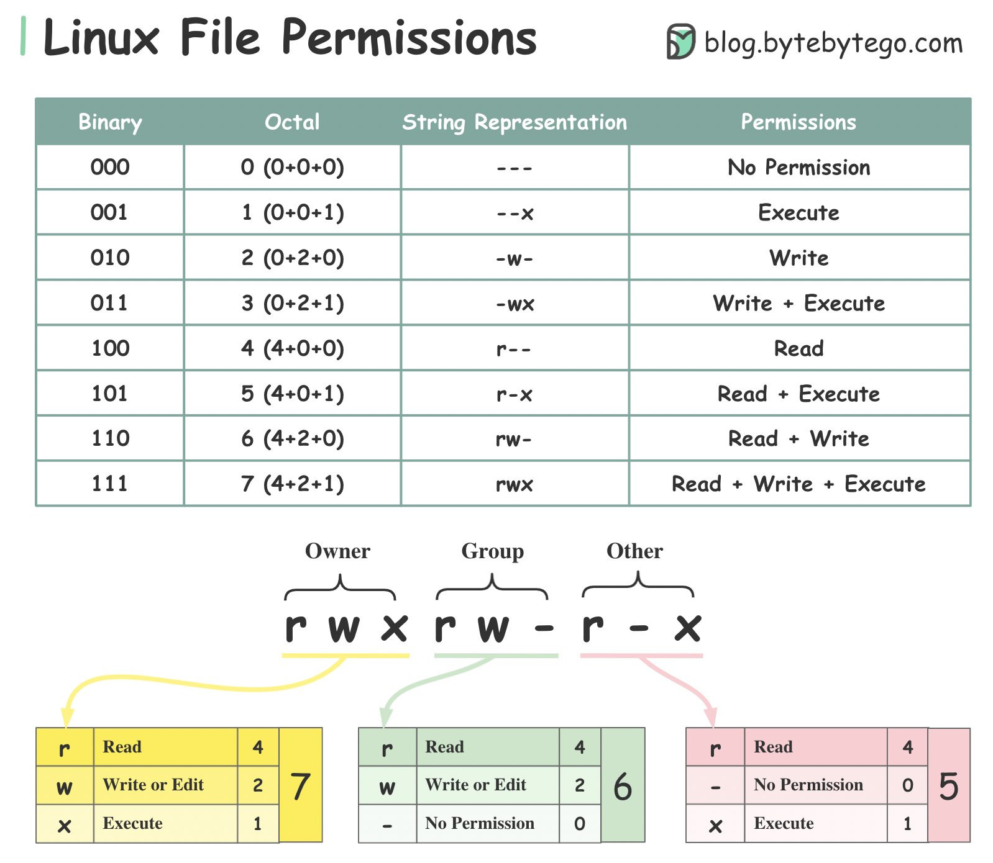

2.3 Viewing Permissions
- To view the permissions of a file or directory, use the ls -l command:
ls -l filename
Example output:
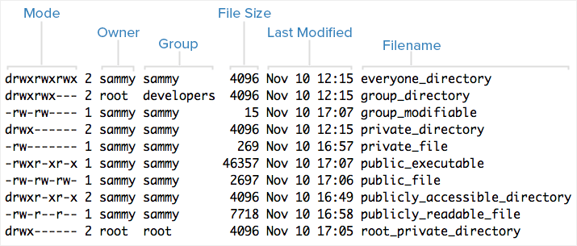
2.4 Changing Permissions
Using chmod
- The chmod command is used to change the permissions of a file or directory. Permissions can be set using symbolic or numeric modes.’

- Symbolic Mode
Symbolic mode uses letters to represent user types and permission types:
- u for owner (user)
- g for group
- for others
- a for all (user, group, and others)
Use + to add a permission, - to remove a permission, and = to set a permission explicitly.
Examples:
Add execute permission for the owner:
chmod u+x filename
- Remove write permission for the group:
chmod g-w filename
- Set read and write permissions for everyone:
chmod a=rw filename
- Numeric Mode
Numeric mode uses octal numbers to represent permissions:
- Read = 4
- Write = 2
- Execute = 1
Permissions are set using a three-digit number, where each digit represents the permissions for the owner, group, and others respectively.
Examples:
Set read, write, and execute permissions for the owner, and read and execute permissions for the group and others:
chmod 755 filename
- Set read and write permissions for the owner, and read-only permissions for the group and others:
chmod 644 filename
- Using chown
The chown command changes the ownership of a file or directory. The syntax is:
chown owner:group filename
Examples:
Change the owner to user and the group to group:
chown user:group filename
Change the owner to the user only:
chown user filename
- Using chgrp
The chgrp command changes the group ownership of a file or directory. The syntax
chgrp group filename
Example:
Change the group to group:
chgrp group filename

Special Permissions
- In addition to the basic permissions, Linux also provides special permissions:
- Setuid (Set User ID): When set on an executable file, allows users to execute the file with the permissions of the file owner.
- Setgid (Set Group ID): When set on a directory, new files created within the directory inherit the group ID of the directory.
- Sticky Bit: When set on a directory, only the file owner can delete or rename files within that directory.
Using chmod for Special Permissions
Special permissions are set using symbolic mode or numeric mode:
- Setuid: u+s (symbolic), 4 (numeric)
- Setgid: g+s (symbolic), 2 (numeric)
- Sticky bit: o+t (symbolic), 1 (numeric)
Examples:
- Set the setuid bit on an executable:
chmod u+s filename
- Set the setgid bit on a directory:
chmod g+s directory
- Set the sticky bit on a directory:
chmod o+t directory
What is setuid (Set User ID)?
- The setuid (Set User ID upon execution) is a special type of file permission given to a file. When set on an executable file, this permission allows the file to be executed with the privileges of the file owner (usually root), rather than the privileges of the user who runs the file.
- Purpose: The primary use of setuid is to allow users to execute files with the permissions of the file owner. This is particularly useful for programs that need to perform tasks that require higher privileges than those possessed by the user running the program.
- Example Use Case:
- A common example is the passwd command. The passwd command needs to modify the /etc/passwd file, which is owned by the root user. By setting the setuid bit, any user can execute passwd and change their password, while the command itself has the necessary permissions to modify the password file.
- Setting setuid: Use the chmod command to set the setuid bit on a file.
chmod u+s filename
- Viewing setuid: When the setuid bit is set, the file's permissions will show an s instead of the owner's execute bit.
-rwsr-xr-x 1 root root 12345 May 25 12:34 filename

What is Sticky Bit?
- The sticky bit is a special type of permission primarily used on directories. When set on a directory, it ensures that only the file's owner, the directory's owner, or the root user can delete or rename files within that directory.
- Purpose: The sticky bit is typically used to protect files in shared directories. It prevents users from deleting or renaming each other's files within a common directory, thus ensuring that users can only manipulate their own files.
- Example Use Case: A common use of the sticky bit is on the /tmp directory, where many users can create files. With the sticky bit set, users can create and modify their files but cannot delete or rename files owned by other users.
- Setting the Sticky Bit: Use the chmod command to set the sticky bit on a directory.
chmod +t directory
- Viewing the Sticky Bit: When the sticky bit is set, the directory's permissions will show a t at the end of the others' execute permission.
drwxrwxrwt 2 user group 4096 May 25 12:34 directory

