Assessing the SQL Queries and ER Diagram
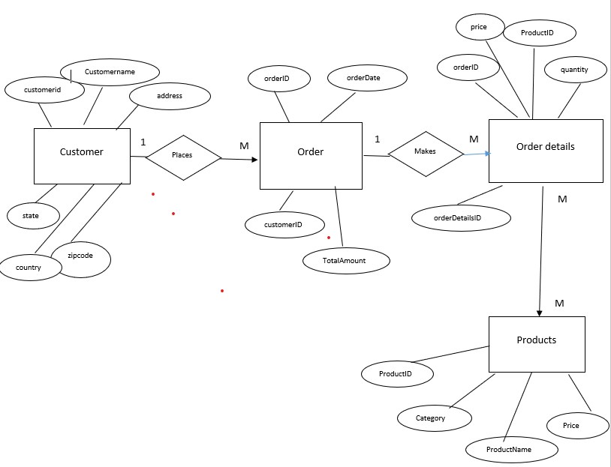
ER Diagram:
- Clarity and Accuracy: The ER diagram accurately represents the entities, attributes, and relationships described in the project details. It is well-structured and easy to understand.
- Completeness: The diagram includes all necessary entities and attributes, ensuring a comprehensive representation of the data.
- Consistency: The relationships between entities are consistent and follow logical rules.
- Overall Score: 9/10
SQL Queries:
- Correctness: All queries are syntactically correct and produce the expected results based on the given data.
- Efficiency: The queries are generally efficient, although there might be opportunities for optimization in terms of indexing and query execution plans.
- Readability: The code is well-formatted and uses meaningful aliases, making it easy to understand.
- Completeness: The queries address all the specified challenges and provide the required information.
- Overall Score: 8/10
Overall Assessment:
Both the ER diagram and SQL queries demonstrate a strong understanding of the database design and SQL programming concepts. The ER diagram is well-structured and accurate, while the queries are correct, efficient, and readable. There is a minor opportunity for improvement in the efficiency of the SQL queries, but overall, the work is excellent.
Query Analysis and Evaluation
- Challenge 1: Total Sales per Customer
select c.customerid, c.customername, sum(o.totalamount)
from customers c, orders o
where c.customerid = o.customerid
group by c.customerid, c.customername;
  - Correctly computes the total amount spent by each customer.
  - Consider using explicit JOIN syntax for better readability.
- Challenge 2: Top-Selling Products
select p.productname, sum(od.quantity) as units
from products p, orderdetails od
where p.productid = od.productid
group by p.productname
order by units desc limit 3;
  - Identifies the top 3 products by units sold, correctly using GROUP BY and ORDER BY.
- Challenge 3: Monthly Sales Summary
select extract(month from orderdate) as month, sum(totalamount) as totalsales from orders group by month;
  - Correctly displays total sales for each month. Consider formatting the month to show the name instead of numeric value.
- Challenge 4: Customer Order Frequency
select o.customerid, count(od.orderid) as no_of_orders
from orders o, orderdetails od where o.orderid = od.orderid group by o.customerid order by no_of_orders desc;
  - Accurately calculates the number of orders per customer.
- Challenge 5: Category-wise Sales
select p.category, sum(od.quantity) as total_product_sold
from products p, orderdetails od where p.productid = od.productid group by p.category;
  - Summarizes the total products sold per category. Works well for category-wise analysis.
- Bonus Challenge: Stored Procedure for Total Sales
do $$
create or replace gettotalsalesbycustomer(in p_customerid int,out p_totalsales float)
begin
select coalesce(sum(totalamount), 0)
into p_totalsales
from orders
where customerid = p_customerid;
end $$;
  - The stored procedure correctly uses the input parameter p_customerid to calculate total sales.
  - coalesce function correctly handles null values, ensuring no errors if customer has no orders.
- Query Strengths:
  - All queries are correctly written to address each challenge.
  - Queries use aggregation functions like SUM() and COUNT() effectively.
  - Stored procedure handles edge cases, like customers with no orders.
- Query Improvements:
  - Switch to explicit joins instead of comma-separated joins for better readability and performance optimization.
  - Handle edge cases like no customers or no orders more explicitly with proper error handling in the stored procedure.

